**A000-Asia-China-Pendant-Philosopher-Jade-Tang-750 CE**

**SHAPE \* MERGEFORMAT 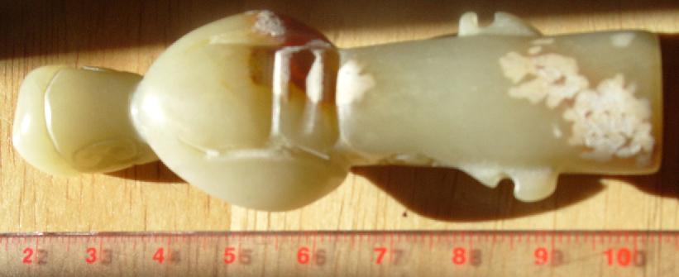 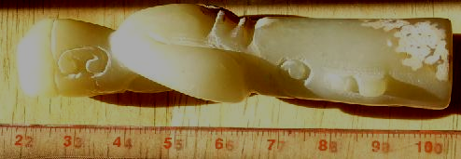 SHAPE \* MERGEFORMAT** 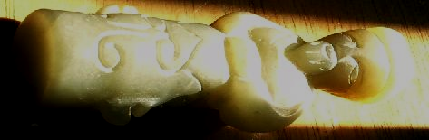 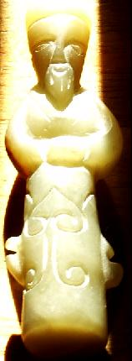

Case no.: 6

Accession Number: A000

Formal Label: **China-Pendant-Philosopher-Jade-Tang-750 CE**

**Display Description:**

**This anthropomorphic pendant, carved of pale grey-white nephrite with rust-brown areas. There is some alteration of the jade which has a smooth polish and edges. The front- bottom of the pendant is incised with bilaterally symmetrical arcs that encompass pendant holes that are now quite worn with once held a pendant string. This arrangement of the pendant holes indicates the when originally worn, the pendant figure would have been suspended up-side-down. This type of suspension may have signified that the figure displayed was deceased and the act of suspending it up-side-down was in reference to its spiritual state.**

**The cicada resurrection amulet in traditional China was based on the life cycle of the cicada which begins as a nymph that having hatched from a egg on a tree branch, falls to the earth, burrows in the ground, and attaches to rootlets where it is sustained by the root's nourishment for as many as seventeen years when they are mysteriously called into the light of day, climb the trunk of the tree, their skins split open, and their wings unfurl as mature cicadas.**

**LC Classification:** NK5750

Date or Time Horizon: **Tang-750 CE**

Geographical Area:

**Map:**

**GPS coordinates:**

Cultural Affiliation: Tang

Medium: **nephrite, pale grey-white**

Dimensions: **H 8.26 cm, 3.25 in**

Weight:

Condition: original

Provenance:

**Discussion:**

**The resurrection metaphor can be applied to either that of the dead being resurrected into new life or in the case of the philosopher emerging from the darkness of the enclosed study being resurrected into the world of light. As De Groot (1892, Pt. 2: 16) remarks "the Chinese regard death as a separation of the vital spirit from the body, and they cling to the belief that the spirit keeps hovering about the body, even after the latter has been deposited in its final resting place." The present figurine according to this interpretation would signify the hovering spirit of the deceased prior to its final emergence as a cicada. Three phases of the emergence of the resurrected spirit represented in Chinese jades from the anthropomorphic, to the quasi anthropomorphic to the true cicada are in the Field Museum of Natural History, Chicago (Harman 1974):**

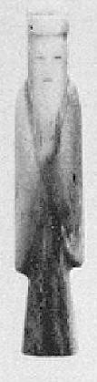 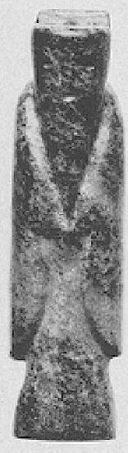 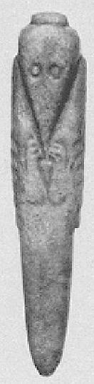

**Field Museum of Natural History, Chicago, Nephrite philosopher pendants, anthropomorphic- quasi cicada. After Hartman 1974, Figs. 8 c, a, b**

**References:**

**Hartman, Joan M. 1974. “**[**An Interesting Han Jade in the Los Angeles County Museum of Art**](https://www-jstor-org.libproxy.mit.edu:9443/stable/3249710)**,”**

[***Artibus Asiae,***](http://www.jstor.org.libproxy.mit.edu/action/showPublication?journalCode=artibusasiae)  Vol. 36, No. 1/2, pp. 55-64

**De Groot, J.J.M. 1892-1910. *The Religious System of China*.** Leyden, E.J. Brill, 1892-1910**. 6 vols.**